New Year’s Day Hike, Christmas Sales, and Living History Program Highlight Cold but Not Quiet Month of December
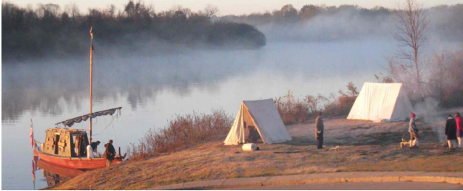
(Photo curtesy of Early Arkansas Reenactors Association)
Though the northern winds have finally brought the winter’s cold to Davidsonville Historic State Park, plenty is happening this December you won’t want to miss out on. Still needing a gift for friends and family this holiday season? The park store can take care of you. Come browse our locally crafted items, park apparel, and other goods to see the great deals and new discounts on selected pieces. After browsing the store, make sure to check out the visitor center exhibits, featuring artifacts from the old town site and a replica flatboat.
Need to get outside and away from the holiday crowds for a bit? Davidsonville is the place to be. The Early Arkansas Reenactors Association launch their 2016 Black River Expedition from the Davidsonville Boat Launch at 8am on December 27th. Join the park interpreter and learn how Arkansans during the 1800s traveled on the river before the Keelboat Aux Arc starts its journey downriver.
For those looking to start a New Year’s Resolution on the right foot, we invite you to join the park interpreter January 1st, from 2-4pm for the annual First Day Hike. This year features an exploration of the park’s 2011 land addition. Lower river levels and bare trees will provide unique views of the park that few visitors get to enjoy during warmer months. After the hike, stick around and enjoy some hot cider or hot chocolate by the fire and make some memories with your fellow park enthusiasts.
For more information about these and other events, please call the park 870-892-4708 or stop by and visit us. Davidsonville is located on Arkansas Highway 166 South, 15 minutes from Pocahontas. The park staff wishes you all happy holidays and hope to see you out at your local state park soon.

