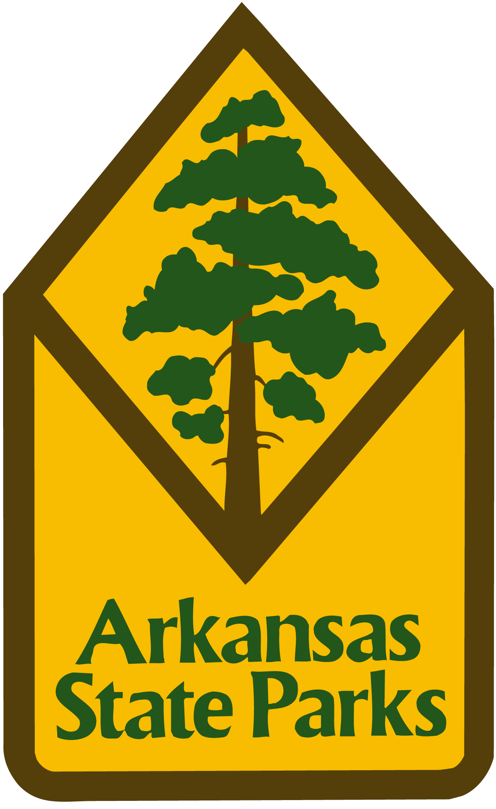
News Release

Davidsonville Historic State Park
8047 Hwy 166 South
Pocahontas, AR 72455

Contact: Kendra Harris, Park Supt
Phone: (870) 892-4708
Fax: (870) 892-0480

FOR IMMEDIATE RELEASE

Upcoming Events at Davidsonville Historic State Park

Gourd Workshop, February 18th, 2017 1-4p.m.
Gourds have been used for centuries for a variety of purposes. Join park staff to learn how to shape and decorate these unique plants and create things like bird houses and holiday decorations. Please dress appropriately as some materials may stain. Must be 18 years or older. Space is limited and early registration is required. Admission: $20 per person

#####

